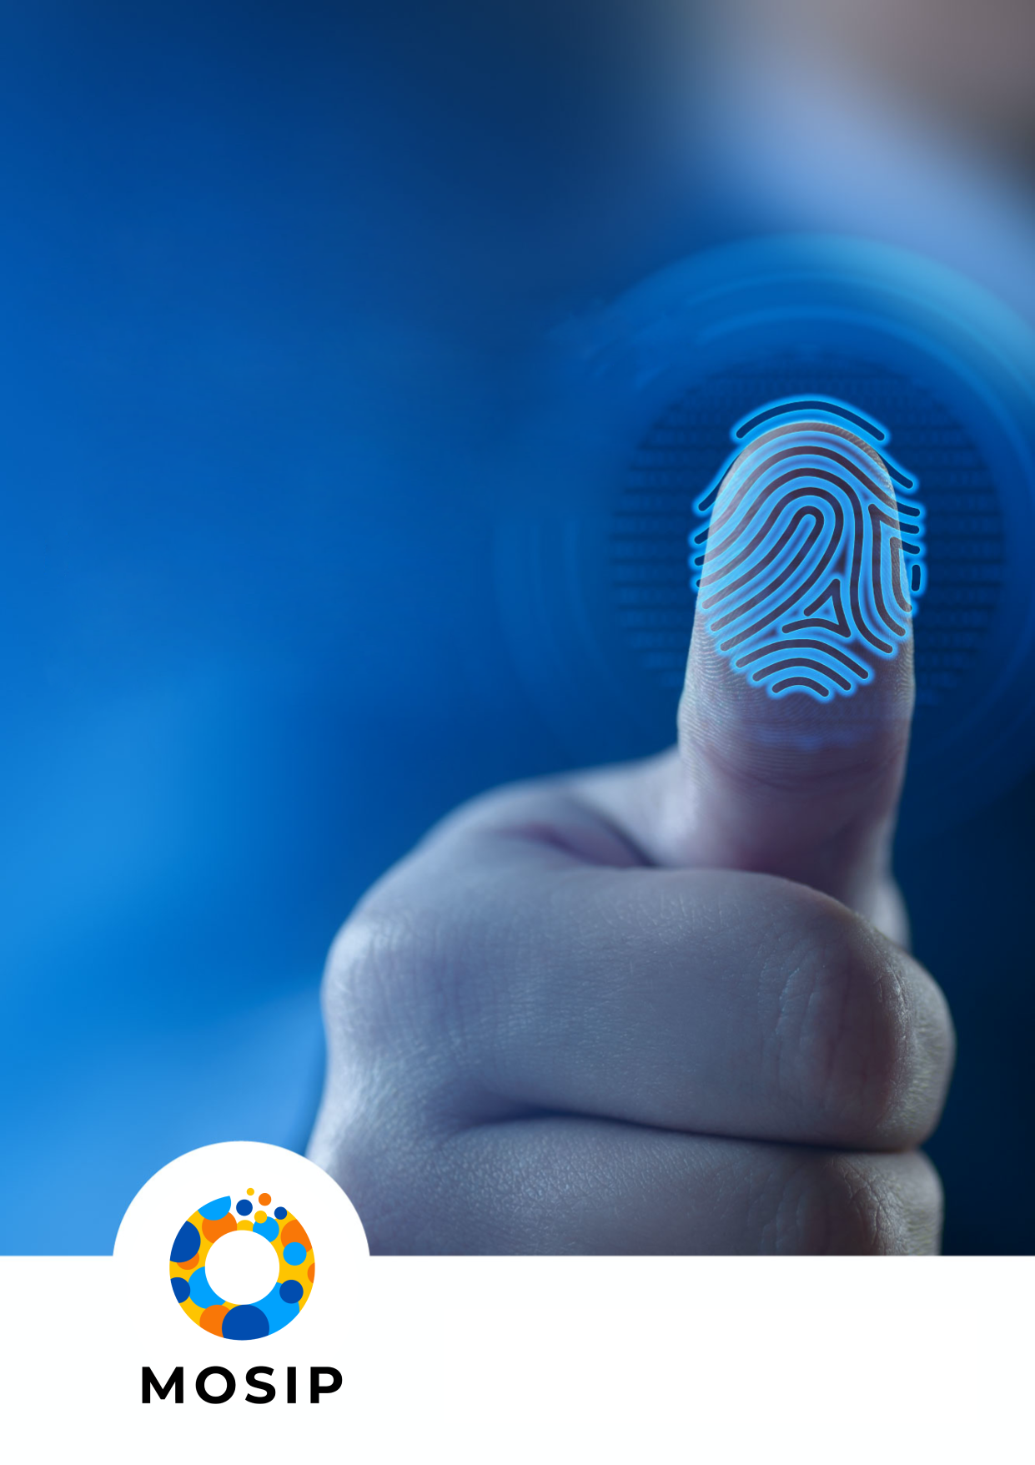

**Draft document produced in collaboration with BixeLab, with assistance from the members of**

**the Biometric Working Group.**

**DEVICE PROFILES**

**MACP BIOMETRIC**

**DEVICE QUALITY CERTIFICATION**

**CRITERIA**

**(DRAFT V1.1)**

## Introduction

In the context of a developing nation's digital identity ecosystem, biometrics are critical for secure and accurate identification in a range of applications such as citizen enrolment, law enforcement, social welfare programs etc.

The quality of biometric data captured during enrolment significantly impacts a system's effectiveness. The modality specific device profiles will assist MOSIP accredited labs in testing the biometric quality of biometric enrolment devices used within a developing nation's digital identity ecosystem, specifically within MOSIP's open-source platform.

Device profiles below outline the testing criteria and metrics for evaluating the quality of biometric enrolment devices within applicable specific use cases. Tables under each modality provide some examples of biometric quality testing criteria for enrolment/registration devices. Note that labs may adapt or expand applicable testing criteria for the evaluation based on factors such as device claims, target usage scenarios, device specifications etc.

Testing criteria will be defined based on two scenarios:

1. **Indoors acquisition:** Controllable acquisition environment (for example, environmental factors such as illumination, weather, temperature, humidity, etc., can be controlled).
2. **Outdoors acquisition:** Uncontrollable acquisition environment (for example, mobile registration scenarios where environmental factors such as illumination, weather etc cannot be controlled).

Providers can undergo testing for either one or both scenarios. A provider must first obtain certification for Indoors acquisition before undergoing assessment for certification for Outdoors acquisition.

Post acquisition, the quality assessment associated with the acquired samples may be undertaken with the help of standard tools such as NFIQ 2.0 for fingerprint. Reporting must clearly indicate the methods used for resolving a pass or a failure outcome associated with the criteria tested.

The MOSIP accredited labs must prepare a detailed test plan with test scenarios and associated pass/fail in compliance with the published MACP Biometric Device Certification Framework for Quality v1.1. This test plan must be approved by all key stakeholders prior to the commencement of the testing process and approval records maintained.

A stronger pass/fail criterion may be established overtime based on industry standards, MOSIP's requirements, and the specific needs of the developing nation's digital identity ecosystem.

Testing to the device profiles will ensure that biometric enrolment devices used in the developing nation's digital identity ecosystem meet the minimum biometric quality standards for reliable and accurate data capture and matching.

## **Fingerprint**

# **Pre-requisites:**

|  |  |
| --- | --- |
| Testing Criteria | Description of evaluated components |
| Image format compliance (pre-requisite) | MOSIP to validate whether the captured fingerprint images conform to the ISO 19794-4:2011 specifications |

# Device profile is specific to assessment of fingerprint registration (enrolment) devices in a supervised collection environment.

# Assumptions:

# Ergonomically suitable positioning of the device

# Indoor (controllable) laboratory environment

# Contact based fingerprint capture (plain or rolled)

# Maximum 3 re-attempts allowed.

| Testing Criteria | | Capture condition | Test Method | Pass Metric | | | |
| --- | --- | --- | --- | --- | --- | --- | --- |
| Successful acquisition Rate | Average acquisition duration | NFIQ 2.0 score (Overall first attempt) – for plain | NFIQ 2.0 score (Overall first attempt) – for rolled |
| Ideal/ Bona fide presentation | | Ideal Indoor Capture Conditions | Capture fingerprint as expected by the capture device | >=75% | <30 seconds | >=30 | >=20 |
| Adverse Quality Conditions (based on a combination of user sensor interaction and/or environmental conditions) | Additional pressure | Indoor | Capture fingerprint images with varying pressure and finger positioning | 50% to 75% | Between 30 to 60 seconds | Between 10 to 20 | Between 5 to 20 |
| Adverse presentation angle | Indoor | Capture fingerprint images with different finger placement angles | 50% to 75% | Between 30 to 60 seconds | Between 10 to 20 | Between 5 to 20 |
| Sweaty Fingerprint: Note, the test criteria is based on user trait (i.e., not based on environmental influencing factors) | Indoor | Capture fingerprint images where user has sweaty/moist fingerprints | 50% to 75% | Between 30 to 60 seconds | Between 10 to 20 | Between 5 to 20 |
| Dry Fingerprint Note, the test criteria is based on user trait (i.e., not based on environmental influencing factors) | Indoor | Capture fingerprint images where user has dry fingerprints | 50% to 75% | Between 30 to 60 seconds | Between 10 to 20 | Between 5 to 20 |
| Low lighting conditions: Note, the test criteria is based on environmental influencing factor such as low lit indoor environment however, extreme outdoor type capture conditions are not covered. | Indoor | Capture fingerprint images with low indoor lighting levels | 50% to 75% | Between 30 to 60 seconds | Between 10 to 20 | Between 5 to 20 |
| wrinkly fingerprint: Note, test criteria is based on environmental factor such as rainy conditions | Outdoor | Capture wrinkly fingerprints in wet or rainy conditions | 50% to 75% | Between 30 to 60 seconds | Between 10 to 20 | Between 5 to 20 |
| Fingerprint in direct sun exposure conditions | Outdoor | Capture fingerprint under direct sun exposure | 50% to 75% | Between 30 to 60 seconds | Between 10 to 20 | Between 5 to 20 |
| Fingerprint in no direct sun exposure conditions | Outdoor | Capture fingerprint under no direct sun exposure | 50% to 75% | Between 30 to 60 seconds | Between 10 to 20 | Between 5 to 20 |

# The pass criteria are based [on the smart borders pilot project report on the technical conclusions of the pilot volume 1](https://www.eulisa.europa.eu/Publications/Reports/Smart%20Borders%20-%20Technical%20Report.pdf). It is expected that the pass/fail criteria will be updated based on the insights from MOSIP accredited labs as they complete testing similar technologies.

| Pass Criteria | | |
| --- | --- | --- |
| Successful acquisition Rate | Green (Pass) | >=75% |
| Orange | 50-75% |
| Red (Fail) | <50% |
| Duration | Green (Pass) | <30 seconds |
| Orange | >=30 seconds but <60 seconds |
| Red (Fail) | >= 60 seconds |
| NFIQ 2.0 score (Overall first attempt) – for plain | Green (Pass) | >=30 |
| Orange | <20 but >=10 |
| Red (Fail) | <10 |
| NFIQ 2.0 score (Overall first attempt) – for rolled | Green (Pass) | >=20 |
| Orange | <20 but >=5 |
| Red (Fail) | <5 |

# Note: Current NFIQ 2.0 thresholds are based on [the Technical Guideline TR-03121-3 Biometrics for Public Sector Applications report](https://www.bsi.bund.de/SharedDocs/Downloads/EN/BSI/Publications/TechGuidelines/TR03121/TR-03121-3_5_Biometrics_4-4.pdf?__blob=publicationFile&v=1). The minimum thresholds will be updated based on the labs’ datapoints established when testing similar technologies.

# Thresholds for plain fingerprints for enrolment.

| Finger | Finger Code | NFIQ 2.0 score Threshold |
| --- | --- | --- |
| Right thumb | 1 | 30 |
| Right index | 2 | 30 |
| Right middle | 3 | 20 |
| Right ring | 4 | 10 |
| Right little | 5 | 10 |
| Left thumb | 6 | 30 |
| Left index | 7 | 30 |
| Left middle | 8 | 20 |
| Left ring | 9 | 10 |
| Left little | 10 | 10 |

# Thresholds for rolled fingerprints for enrolment.

| Finger | Finger Code | NFIQ 2.0 score Threshold |
| --- | --- | --- |
| Right thumb | 1 | 20 |
| Right index | 2 | 15 |
| Right middle | 3 | 15 |
| Right ring | 4 | 10 |
| Right little | 5 | 5 |
| Left thumb | 6 | 20 |
| Left index | 7 | 15 |
| Left middle | 8 | 15 |
| Left ring | 9 | 10 |
| Left little | 10 | 5 |

## **IRIS**

# **Pre-requisites:**

| Testing Criteria | Description of evaluated components |
| --- | --- |
| Image format compliance (pre-requisite) | MOSIP to validate whether the captured iris images conform to the ISO 19794-6:2011 specifications |

# Device profile is specific to assessment of iris registration devices in a supervised collection environment.

# Assumptions:

# Ergonomically suitable positioning of the device

# Indoor (controllable) laboratory environment

# Device capture enrol both irises

# Maximum 3 re-attempts allowed.

# **NOTE:**

# Since iris modality is impacted by demographic variables, the test crew must adequately represent the physiological traits of the target population, for example, some geographies have a higher percentage of dark eyed individuals as opposed to other geographies.

# The device profile does not consider test crew with medical conditions, usage patterns that may result from uncontrollable factors such as age.

| Testing Criteria | | Capture condition | Test Method | Pass Metric | | | | | | | | | |
| --- | --- | --- | --- | --- | --- | --- | --- | --- | --- | --- | --- | --- | --- |
| Successful Acquisition Rate | Average acquisition duration | Greyscale utilisation | Iris pupil concentricity | Iris pupil contrast | pupil dilation | Iris sclera contrast | Margin adequacy | Pupil boundary circularity | Usable iris area |
| **Ideal/ Bona fide presentation** | | Ideal Indoor Capture Conditions | Capture iris images with subjects' eyes wide open and looking directly at the device using the device | >=75% | < 30 seconds | >=6 | >=90 | >=30 | Between 20 and 70 | >5 | >80 | 100 to a circle and [0,100] to other forms | >=70 |
| **Adverse Quality Conditions (based on a combination of user sensor interaction and/or environmental conditions)** | Presentation with eyewear | Indoor | Capture iris images with subject wearing clear glasses or contact lenses | 50% to 75% | Between 30 to 60 seconds | >=6 | >=90 | >=30 | Between 20 and 70 | >5 | >80 | 100 to a circle and [0,100] to other forms | >=70 |
| Large subject to camera distance | Indoor | Capture iris with subject present at a distance > 1 meter from the capture device | 50% to 75% | Between 30 to 60 seconds | >=6 | >=90 | >=30 | Between 20 and 70 | >5 | >80 | 100 to a circle and [0,100] to other forms | >=70 |
| Presentation with patterned contacts | Indoor | Capture iris with subject wearing patterned contact lenses | 50% to 75% | Between 30 to 60 seconds | >=6 | >=90 | >=30 | Between 20 and 70 | >5 | >80 | 100 to a circle and [0,100] to other forms | >=70 |
| Dilated pupil presentation | Outdoor | Capture iris images with subjects’ pupils at different dilation levels | 50% to 75% | Between 30 to 60 seconds | >=6 | >=90 | >=30 | Between 20 and 70 | >5 | >80 | 100 to a circle and [0,100] to other forms | >=70 |
| Constricted pupil presentation | Outdoor | Capture iris images with subjects’ pupils at different constricted levels | 50% to 75% | Between 30 to 60 seconds | >=6 | >=90 | >=30 | Between 20 and 70 | >5 | >80 | 100 to a circle and [0,100] to other forms | >=70 |
| Occluded presentation | Outdoor | Capture iris images with subject blinking owing to conditions such as windy weather which may result in iris being occluded | 50% to 75% | Between 30 to 60 seconds | >=6 | >=90 | >=30 | Between 20 and 70 | >5 | >80 | 100 to a circle and [0,100] to other forms | >=70 |

# Note: For adverse quality tests, where a sample is acquired, the ISO/IEC 29794-6 specified quality metrics per sample must meet the same thresholds as set for bona fide tests.

| Pass criteria | | |
| --- | --- | --- |
| Successful acquisition Rate (both left and right iris patterns) above a given threshold within three attempts | Green (Pass) | >=75% |
|  |  |
| Fail |  |
| Duration | Green (Pass) | <30 seconds |
| Orange | >=30 seconds but <60 seconds |
| Red (Fail) | >= 60 seconds |
| [ISO/IEC 29794-6:2015 [Information technology – Biometric sample quality – Part 6: iris image data][1]](https://www.iso.org/standard/54066.html) | Greyscale utilization [0, +inf): The spread of intensity values regarding the pixel values within the iris portion of the image. | >=6 |
| Iris pupil concentricity [0,100]: The degree to which the pupil center and the iris center are in the same location. | >=90 |
| Iris pupil contrast [0,100]: The image characteristics at the boundary between the iris region and the pupil. | >=30 |
| Pupil dilation (9.58, 121.30): The degree to which the pupil is dilated or constricted | Between 20 and 70 |
| Iris sclera contrast [0,100]: The image characteristics at the boundary between the iris region and the sclera. | >5 |
| Margin adequacy [0,100]: The degree to which the iris portion of the image is centered relative to the edges of the entire image. | >80 |
| Pupil boundary circularity [0,100]: The circularity of the iris-pupil boundary. | 100 to a circle and [0,100] to other forms |
| Usable iris area [0,100]: The fraction of the iris portion of the image that is not occluded by eyelids, eyelashes, or specular reflections. | >=70 |

## **FACE**

# **Pre-requisites:**

| Testing Criteria | Description of evaluated components |
| --- | --- |
| Image format compliance (pre-requisite) | MOSIP to validate whether the captured face images conform to the ISO 19794-5 specifications |

# Device profile is specific to assessment of face capture/registration/enrolment devices in a supervised collection environment.

# Assumptions:

# Ergonomically suitable positioning of the device

# Indoor (controllable) laboratory environment

# Maximum 3 re-attempts allowed.

# **NOTE:**

# Since face modality is impacted by demographic variables, the test crew must adequately represent the physiological traits of the target population.

# The device profile does not consider test crew with medical conditions, usage patterns that may result from uncontrollable factors such as age.

| Testing Criteria | | Capture condition | Test Method | Pass Metric | | |
| --- | --- | --- | --- | --- | --- | --- |
| Successful acquisition rate | Average acquisition duration | Quality Score (unified) |
| Ideal/ Bona fide presentation | | Ideal Indoor Capture Conditions | Capture face as expected by the capture device | >=75% | <30 seconds | >=50 |
| Adverse Quality Conditions (based on a combination of user sensor interaction and/or environmental conditions) | Pose variation | Indoor | Capture face with adverse pose angles | 50% to 75% | Between 30 to 60 seconds | >=50 |
| Occluded presentation | Indoor | Capture face with partial occlusions owing to clear glasses, facial hair, scarves, etc. | 50% to 75% | Between 30 to 60 seconds | >=50 |
| Expression variation | Indoor | Capture face with extreme facial expressions such as smile, or frowning | 50% to 75% | Between 30 to 60 seconds | >=50 |
| Eyes closed | Indoor | Capture face images with subjects’ eyes closed during capture | 50% to 75% | Between 30 to 60 seconds | >=50 |
| Illumination variation | Outdoor | Capture face in direct sunlight condition | 50% to 75% | Between 30 to 60 seconds | >=50 |
| Illumination variation | Outdoor | Capture face in not direct sunlight (shadow) condition | 50% to 75% | Between 30 to 60 seconds | >=50 |
| Multiple people (e.g., people in the background) | Outdoor | Capture face images with multiple faces | 50% to 75% | Between 30 to 60 seconds | >=50 |
| Blur | Outdoor | Capture face images with subjects’ face out of focus/in motion causing blur in captured image | 50% to 75% | Between 30 to 60 seconds | >=50 |

# Note that the pass metrics are currently based on the working draft ISO/IEC 29794-5:2022 and will be revised once the standard is published and as labs evaluate similar technologies and establish traceable datapoints to set thresholds for passing. Currently set pass metric for the unified quality score has been set on the basis of the sample utility being mapped to the quality-false rejection correlation – as has been done in the case of NFIQ 2 metric.

# Specifications outlined in Annex B Applications of quality values apply when assessing face acquisition devices under the certification.

| Pass Criteria | | |
| --- | --- | --- |
| Successful acquisition Rate above a given threshold within three attempts or successful rejection rate for adverse presentation cases with ground truth set as reject. | Green (Pass) | >=75% |
| Orange | 50-75% |
| Red (Fail) | <50% |
| Duration | Green (Pass) | <30 seconds |
| Orange | >=30 seconds but <60 seconds |
| Red (Fail) | >= 60 seconds |
| ISO/IEC 29794-5:2022 (WD5)[2] | Quality score (unified) [0,100] | >=50 |

# Note: For adverse quality tests, where a sample is acquired, the ISO/IEC 29794-5 specified quality metrics per sample must meet the same thresholds as set for bona fide tests.

## Comments and Questions

#### June 23:

# **Comment – T. Dunstone**

# Pass/fail criteria:

# Distribution of scores per testing criteria may be established by the labs overtime as they undertake evaluations in initial phases. This way, deviations from expected distribution of quality attributes will be available to the labs overtime.

# **Questions – S. Singh**

# How to set a clear pass/fail on Face Modality?

# How to set ground truth on aspects relating to eyewear tolerance/iris image quality/pupil variation/blinking tolerance and occlusion handling?

### September 23:

# **Comment – S. Sundaram**

# Step-by-step instructions and pass/fail criteria for each.

# **Comments and Questions – Meilee Ngan**

# Will indoors and outdoors be qualified a bit more (is it that indoors has more controlled illumination, weather, temperature, humidity, etc.? Is collection inside a tent considered indoors or outdoors?

# Perhaps break this table [Fingerprints table] up into "indoor" test vs. "outdoor" test or add a column that says "indoor or outdoor or both". Would we expect moist conditions under an indoor scenario?

# Is this doing a form of presentation attack detection? Is this in scope for this document? – on latent fingerprint test case for fingerprint profile

# This seems to be related to occlusion handling in that if the device detects that the iris collected is occluded due to blinking, it would trigger a recollect? – on blinking tolerance test case for iris profile

# My assumption here is that we don’t want the device to capture and store images that don’t conform to ISO 19794-5? If that’s indeed the case, then the device should detect poor illumination, non-frontal pose, occlusion, and non-neutral expression and reject the image/trigger a recollect. – on face profile.

# **Question – Alexandra**

# Are considering any direct sun/no direct sun exposure when collecting or shadow factor? Optical scanners (and particularly multi-spectral) operate really badly in bright sun (outdoors), so the contract might be good and the area might be good, but the actual image is either blacked out or has a strong shadow that often leads to poor matching scores. – on fingerprint profile.

|  |  |  |  |
| --- | --- | --- | --- |
| Version | Description | Date | Author |
| 0.1 | First drafts | June 23 | T. Dunstone, S. Singh |
| 0.2 | Feedback from T.D., S | September 23 | S. Sundaram, T. Dunstone |
| 0.3 | Addressed feedback from MOSIP WG members | October 23 | T. Dunstone, S. Singh |

1. # This is based on published standard and https://github.com/mitre/biqt-iris for now. The minimum pass thresholds may be updated overtime as the labs evaluate similar technologies with traceable datapoints.

  
2. This is based on the published draft standard for now. The minimum pass thresholds may be updated overtime as the labs evaluate similar technologies with traceable datapoints.